Outlook by default will send it with your personal email and this is an issue if it's emails that have to be found in cash's sent folder. Below is how to set up sending "On Behalf of CashDepartment" so that it stays in cash's sent folder just like Lotus Notes:

1. New email
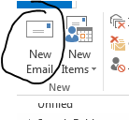

2. Click the drop arrow on the From box and click "Other E-mail Address…"

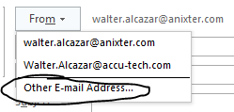

3. Start typing the first few letters and it will find the cashdepartment email:

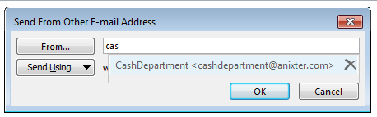

4. Hit enter to accept the suggestion and Ok to finish. Now your email will be sent with a title "Your Name on Behalf of CashDepartment" and will stay in Cash's sent folder.

